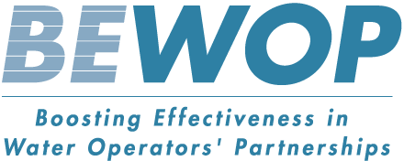

WOPs are peer-support arrangements between two or more water and sanitation operators, carried out on a not-for-profit basis with the objective of strengthening operator capacity.

BEWOP is a 5-year initiative aimed at boosting the effectiveness of Water Operator Partnerships around the world.

The project partners co-develop and test together with water professionals involved in the daily operations of partnerships a series of practical tools.

The tools and games developed under BEWOP attempt to support the learning between staff in WOPs by enhancing and supporting the opportunities generated within the partnership.

**FIND OUT MORE**

bewop.un-ihe.org/

GWOPA.org

un-ihe.org

**BEWOP TOOLS**

****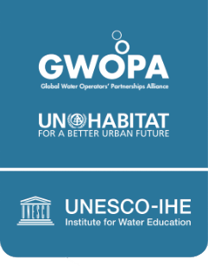

**HOW IT WORKS**

Within a (water) utility, managers are tasked with achieving numerous, often conflicting objectives: full service coverage, high water quality, service affordability, adequate infrastructure operation and maintenance, HR management, bankability. Achieving these objectives simultaneously is tough and often involves foreseeing potential consequences and making trade-offs on investment and priorities.

The Utility Management Simulation Game groups players into teams of 4, with each player taking on the role of either a General, Financial, Commercial or Operational manager to run a utility for 10 years. Based on data from a real utility from a developing country, players must work together to make strategic decisions on the best way forward to improve key performance indicators.

Several teams can play at once to compete (or just explore) how their decisions result in often unexpected outcomes.

Can you keep the utility from going bankrupt? Will service quality bring in more financial resources? What happens when your assumptions change? See how you would cope with this by playing the game.

**BEWOP Operational Tools**

**Utility Management Simulation Game**

***[Insert graphic – “People using the tool”]***

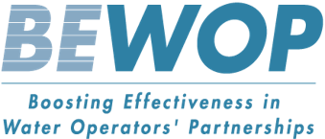

**OBJECTIVE**

The Utility Simulation Game has been designed as a learning tool to develop awareness and knowledge of the processes of strategic planning within utilities.

The game can be used as a team building or learning exercise for students, utility staff or other water professionals.

The Utility Management Simulation Game is played with a facilitator or trainer who guides discussions on how decisions, trade-offs and actions play out in everyday business practices, and throws in some surprise elements.

The game draws from real cases and practical experience of experts, which allows participants to experience utilities’ decision making dilemmas in a safe environment.

**FEATURES**

* Easy to use: Excel-based and available offline
* Gaming principles combined with strategy development
* Simulation based on real data from a real utility
* Set of 20+ decisions that can be taken depending on the purpose of the game
* Compare your performance and compete with up to 4 utilities.
* Combine funding from grants and self-financing to improve efficiency
* Assess your performance based on different Key Performance Indicators
* Capacity to replay previous turns and see how different decisions would change your performance